Week 1 Assignment: SRS Document Development
Justin Stewart
CST499: Capstone for Computer Software Technology
Prof. Elchouemi
3/6/2023

Software Requirements Specification
for
Online Course Enrollment System
Version 1.0 approved
Prepared by Justin Stewart
The University of Arizona Global Campus
Originally Written: 3/06/2023
Table of Contents
Table of Contents ii
Revision History ii
1. Introduction 1
1.1 Purpose 1
1.2 Document Conventions 1
1.3 Intended Audience and Reading Suggestions 1
1.4 Product Scope 1
1.5 References 1
2. Overall Description 2
2.1 Product Perspective 2
2.2 Product Functions 2
2.3 User Classes and Characteristics 2
2.4 Operating Environment 2
2.5 Design and Implementation Constraints 2
2.6 User Documentation 2
2.7 Assumptions and Dependencies 3
3. External Interface Requirements 3
3.1 User Interfaces 3
3.2 Hardware Interfaces 3
3.3 Software Interfaces 3
3.4 Communications Interfaces 3
4. System Features 4
4.1 System Feature 1 4
4.2 System Feature 2 4-5
5. Other Nonfunctional Requirements 5-6
5.1 Performance Requirements 5
5.2 Safety Requirements 5
5.3 Security Requirements 5
5.4 Software Quality Attributes 5
5.5 Business Rules 6
6. Other Requirements 6
Appendix A: Glossary 7
Appendix B: Analysis Models 7-11
References 12

Revision History
Name | Date | Reason For Changes | Version
Justin Stewart | 4/3/2023 | Expanded Appendix B w/ Models | Added Reference Page | 1.1

Introduction

Purpose
The purpose of this Software Requirements Specification (SRS) document is to specify the requirements for the development of an Online Course Enrollment System, which will address the problem of students enrolling in online courses. This SRS document covers the entire system, including the registration process, course listing, enrollment, and waiting list.

Document Conventions
This SRS document follows the IEEE 29148-2018 Standard for SRS documentation (IEEE Standards Association, 2018). Each requirement statement has a unique identifier and priority level. The priority levels are used to distinguish the importance of each requirement (Tsui, Bernal, & Karam, 2023, p.119).

Intended Audience and Reading Suggestions
The intended audience for this document includes developers, project managers, testers, and documentation writers. The document is organized into sections that are most pertinent to each reader type. Developers and testers should focus on sections 2 and 3, while project managers and documentation writers should review all sections.

Product Scope
The Online Course Enrollment System is a web-based application that allows students to register, view available courses, and enroll in courses offered during the three semesters per year. The system provides students with the ability to add themselves to the waiting list if a course is full and cancel enrollment from any enrolled course. The system also registers and notifies the first student on the waiting list if a spot becomes available.

References
The following documents and web resources are referenced in this SRS:

Standards: This document outlines the industry standards that the system must adhere to. Title: Industry Standards for Online Education Systems, Author: International Standards Organization, Edition: 2, Date: November, 2016, Source: https://www.iso.org/standard/70708.html.

Standards: This document outlines the industry standards that this document must adhere to. Title: ISO/IEC/IEEE International Standard - Systems and software engineering -- Life cycle processes -- Requirements engineering, Author: IEEE Standards Association, Version: 29148-2018, Date: November, 2018, Source: https://standards.ieee.org/ieee/29148/6937/.

Overall Description

Product Perspective
The Online Course Enrollment System is a new, self-contained product that is not part of a larger system. The system is designed to be scalable and easy to use, providing a user-friendly interface for students to enroll in online courses.

Product Functions
The major functions of the Online Course Enrollment System are:

- New user registration and profile creation
- Login for registered users
- Course listing and enrollment
- Maximum number of enrollments per course
- Waiting list for full courses
- Enrollment cancellation and notification to the waiting list

User Classes and Characteristics
The following user classes are anticipated to use the system:

- Students: The primary users of the system who will register, view available courses, and enroll in courses.
- Administrators: System administrators who will manage the system, including adding and removing courses, managing enrollment limits, and monitoring the waiting list.

Operating Environment
The Online Course Enrollment System is a web-based application that will operate on any modern web browser. The system will be hosted on a web server that meets the minimum requirements of the software used to build the system.

Design and Implementation Constraints
The following constraints will limit the options available to the developers:

- The system must be built using a web-based programming language such as PHP.
- The system must use a SQL database to store user and course information.
- The system must be designed to handle a large number of users and courses.
- The system must follow security protocols to protect user data.

User Documentation
The following user documentation components will be delivered with the software:

- User manual / Readme

Assumptions and Dependencies
The following assumptions and dependencies are made in the development of the Online Course Enrollment System:

- The system will use a standard web server and database management system.
- The system will use an email service or profile page to notify users of enrollment changes.
- The system will comply with all applicable laws and regulations regarding data privacy and security.

External Interface Requirements

User Interfaces
The software product shall provide a graphical user interface (GUI) for users to interact with the system. The GUI shall include standard buttons and functions, such as Profile and Logout, that will appear on every screen. Error messages shall follow standard display guidelines and provide clear and concise explanations of the error.

Hardware Interfaces
The software product shall not have any hardware interfaces, although it may be expanded to include various components such as: barcode scanners, printers, and cash drawers.

Software Interfaces
The software product shall communicate with the following software components: PHP 8.2.3 and MySQL 8.0. The system shall receive and send data to the MySQL database via PHP's MySQLi extension (php, n.d., para.3). The system shall communicate with the operating system via standard PHP functions. The PHP language and MySQL database shall provide the underlying framework for the software product.

Communications Interfaces
The software product shall support communication via HTTP. The system shall provide electronic forms for users to submit requests, and these requests shall be processed and stored in the MySQL database. The system will use an email service or profile page to notify users of enrollment changes. The software product shall support secure communication via Secure Sockets Layer (SSL) and Transport Layer Security (TLS) for all data transmitted over the internet, including email notifications.

System Features

Customer Management
4.1.1 Description and Priority
The customer management feature shall allow users to create, update, and delete customer records. This feature shall have a high priority, as it is essential to the business process.
4.1.2 Stimulus/Response Sequences
- The user selects the customer management option from the main menu.
- The system displays a list of existing customers.
- The user selects an existing customer to view or modify their information or selects the add customer option to create a new customer record.
- The system displays a form for the user to input or modify customer information.
- After the user completes the form, the system saves the information and returns to the customer list.
4.1.3 Functional Requirements
REQ-1: The system shall allow users to create a new customer record by entering the customer's name, address, phone number, and email address.
REQ-2: The system shall allow users to modify an existing customer record by selecting the record and making changes to the customer's name, address, phone number, and email address.

Class Registration
4.2.1 Description and Priority
The Class Registration feature allows users to register for classes offered by the institution. This feature shall have a high priority, as it is a core component of the institution's academic services.
4.2.2 Stimulus/Response Sequences
- The user selects the Class Registration option from the main menu.
- The system displays a list of available classes.
- The user selects a class to Register for and selects Register Course.
- If the Class has room, the user is registered.
- If the Class is full, the user is added to the waitlist of the course. If a student leaves a course with a pending waitlist, the first student on the waitlist is registered into the course.
- The system verifies that the user meets the course prerequisites, checks for class availability, and registers the user for the selected class.
- The system displays a confirmation message with the registered class information.
4.2.3 Functional Requirements
REQ-1: The system shall allow users to browse the list of available classes for the upcoming semester or quarter.

REQ-2: The system shall allow users to view class details such as course description, prerequisites, instructor information, and schedule.

REQ-3: The system shall allow users to register for a class by selecting the Register option and class availability.

REQ-4: The system shall send a confirmation message to the user with the registered class information.

REQ-5: The system shall maintain accurate records of user registrations and class availability.

Other Nonfunctional Requirements

Performance Requirements
The software product shall respond to user actions within 2 seconds, except when retrieving or updating data from the SQL Server database, which may take up to 10 seconds due to network latency. The system shall support up to 500 concurrent users.

Safety Requirements
The software product shall not have any safety requirements.

Security Requirements
The software product shall require user authentication with a username and password. User passwords shall be encrypted and stored securely in the SQL Server database. The system shall provide role-based access control to restrict user access to specific system features. All communication between the software product and the SQL Server database shall be encrypted.

Software Quality Attributes
The software product shall be reliable, maintainable, and usable. The system shall be available 24/7,

Business Rules
- Only registered users can access the system and perform any actions.
- Users can cancel enrollment from any course that they are enrolled in.
- Only administrators can add and remove courses, manage enrollment limits, and monitor the waiting list.

Other Requirements
- The system must adhere to all relevant data protection and privacy laws.
- The system must be able to handle course enrollments for a minimum of 500 students.
- The system must be able to handle a large of amount of data storage and retrieval.
- The system must be able to handle frequent software updates and maintenance.
Appendix A: Glossary
Data protection: The practice of protecting personal information from unauthorized access, use, or disclosure.
IEEE: Institute of Electrical and Electronics Engineers
SRS: Software Requirements Specification
Appendix B: Analysis Models
B.1 Class Diagram
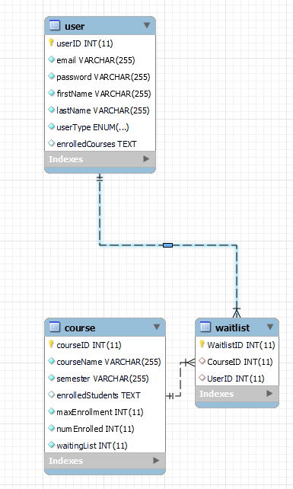

B.2 Use Case Diagram
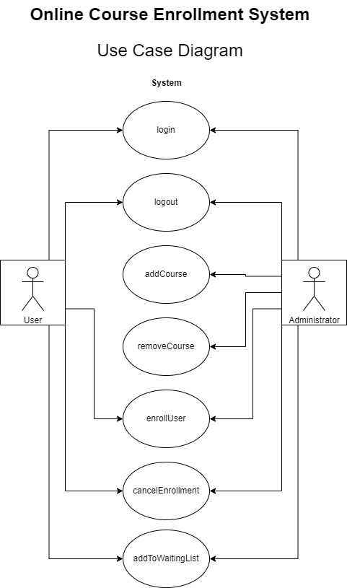

B.3 Activity Diagram
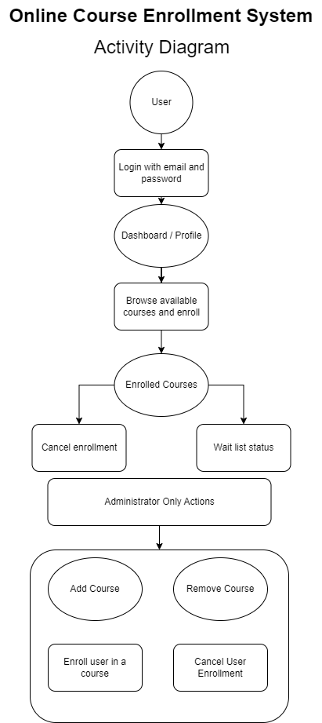

B.4 Sequence Diagram
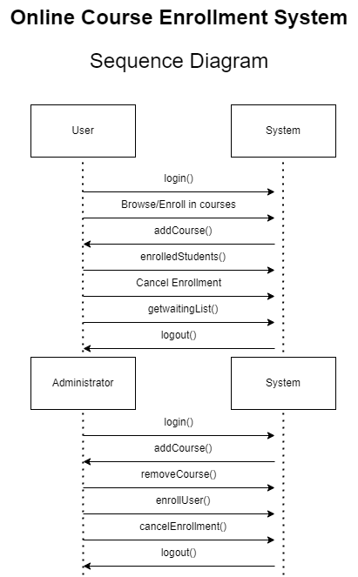

B.5 State Diagram
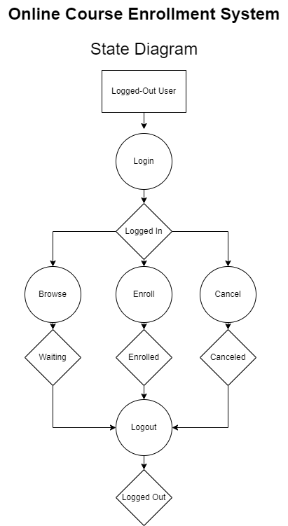

References
IEEE SA - ISO/IEC/IEEE International Standard - Systems and software engineering -- Life Cycle Processes -- Requirements Engineering. IEEE Standards Association. (2018). Retrieved March 6, 2023, from https://standards.ieee.org/ieee/29148/6937/
ISO 18446:2016. ISO. (2016, November). Retrieved March 6, 2023, from https://www.iso.org/standard/70708.html
php. (n.d.). MySQL improved extension. php. Retrieved March 6, 2023, from https://www.php.net/manual/en/book.mysqli.php
Tsui, F. F., Bernal, B., & Karam, O. (2023). Essentials of software engineering. Jones
& Bartlett Learning.

